|  |
| --- |
| **Philly CRM 311**  **Technical Design – Rubbish Recyclable Material Collection**  **V1.1** |
|  |

# REVISION HISTORY

|  |  |  |  |
| --- | --- | --- | --- |
| **Revision Number** | **Revision Date** | **Summary of Changes** | **Author** |
| Draft | 01/26/2014 | Created Draft | Murugaboopathi |
| 1.0 | 02/09/2014 | Updated based on review comments and updated requirement | Murugaboopathi |
| 1.1 | 04/16/2014 | Updated based on review comments and updated requirement 1.7 | Murugaboopathi |

# 1 - TABLE OF CONTENTS

REVISION HISTORY 2

1 - TABLE OF CONTENTS 3

2 – SERVICE REQUEST INFORMATION 4

2.1 ENTITY RELATIONSHIP DIAGRAM 5

2.2.1 CASE STANDARD FIELDS 6

2.2.2 CASE ADDITIONAL FIELDS FOR RUBBISH COLLECTION 6

2.2.3 Force.com Objects 10

2.3 HIGH LEVEL SYSTEM PROCESS FLOW 11

3 - NEW FUNCTIONALITY 12

3.1 CONFIGURATION DETAILS 12

3.2 DATA SHARING MODEL 15

3.3 CUSTOM DEVELOPMENT DETAILS 16

4 – STANDARD CASE FIELDS 20

4.1 DEPARTMENT DETAILS SECTION 20

4.2 CASE DETAIL/INFORMATION SECTION 22

4.3 SERVICE REQUEST LOCATION SECTION 25

4.4 CASE LOCATION SECTION 25

4.5 DESCRIPTION INFORMATION SECTION 25

4.6 RESOLUTION INFORMATION SECTION 27

4.6 WEB INFORMATION SECTION 27

4.7 SYSTEM INFORMATION SECTION 28

# 2 – SERVICE REQUEST INFORMATION

|  |  |
| --- | --- |
| **Case Record Type :** | Rubbish/Recyclable Material Collection |
| **Service Request ID** | SR-ST03: Rubbish/Recyclable Material Collection |
| **Service Request Type** | Rubbish/Recyclable Collection |
| **Department** | Streets |

|  |
| --- |
| 2.1 ENTITY RELATIONSHIP DIAGRAM |

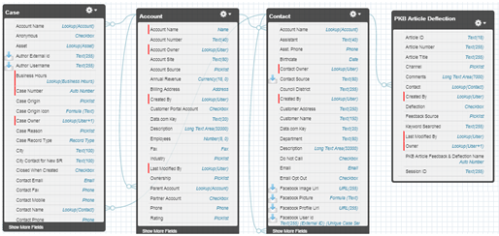

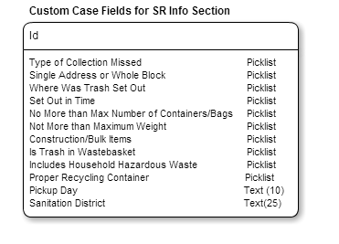

|  |
| --- |
| 2.2.1 CASE STANDARD FIELDS |

|  |  |  |  |  |  |  |  |  |  |
| --- | --- | --- | --- | --- | --- | --- | --- | --- | --- |
| **Field Label** | **Field Name** | **Data Type** | **Required** | **Unique** | **Default Value** | **External ID** | **Rule #** | **History** | **Help Text** |
| Status | Status | Picklist  **Values:** New, In-Progress, Escalated, On Hold, and Closed | Yes | No | New | No | None | Yes |  |
| Case Origin | Origin | Picklist  **Values:** Phone, Email, Web | Yes | No | Phone | No | None | Yes |  |
| Priority | Priority | Picklist  **Values:** High, Medium, Low | Yes | No | Medium | No | None | Yes |  |

|  |
| --- |
| 2.2.2 CASE ADDITIONAL FIELDS FOR RUBBISH COLLECTION |

|  |  |  |  |  |  |  |  |  |  |
| --- | --- | --- | --- | --- | --- | --- | --- | --- | --- |
| **Field Label** | **Field Name** | **Data Type** | **Required** | **Unique** | **Default Value** | **External ID** | **Rule #** | **History** | **Field Help Text** |
| Type of Collection Missed | Type_of_Rubbish_Missed__c | Picklist  **Values:** Rubbish, Recycling, Both | Yes |  |  |  | None | No | What collection items were missed |
| Single Address or Whole Block | Single_Address_or_Whole_Block__c | Picklist  **Values:** Single Address, Block | Yes |  |  |  | None | No | Entire street missed or just one address |
| Where Was Trash Set Out | Where_Was_Trash_Set_Out__c | Picklist  **Values:** Curbside, Common Driveway, Alley, Other | Yes |  |  |  | Workflow Rule #1 | No | A common driveway is shared by multiple properties, usually at the rear of the property. Curbside is at the curb edge of the property. |
| Set Out in Time | Set_Out_in_Time__c | Picklist  **Values:** Yes, No | Yes |  |  |  | Workflow Rule #1 | No | From October 1 through March 31, trash and recycling should be set out between 5:00 PM the night before collection day and 7:00 AM the day of collection. Set-out times from April 1 to September 30 will return to 7:00 PM the night before and by 7:00 AM the day of collection. |
| No More than Max Number of Containers/Bags | Not_More_than_Maximum_Number_of_Receptac__c | Picklist  **Values:** Yes, No | Yes |  |  |  | Workflow Rule #1 | No | Single-family household is allowed a maximum of four (4) 32 gallon containers or eight (8) 30 – 32 gallon bags of trash each week. All other premises are allowed a maximum of six (6) 32 gallon containers or twelve (12) 30 - 32 gallon bags. |
| Not More than Maximum Weight | Not_More_than_Maximum_Weight__c | Picklist  **Values:** Yes, No | Yes |  |  |  | Workflow Rule #1 | No | The weight limit for a bag or can is 40 lbs. The total weight should not exceed 240 lbs. |
| Construction/Bulk Items | Construction_Bulk_Items__c | Picklist  **Values:** Yes, No | Yes |  |  |  | Workflow Rule #1 | No | Rubbish cannot contain construction debris, house/apartment clean out, bulk items, bricks etc. |
| Is Trash in Wastebasket | Is_Trash_in_a_Wastebasket__c | Picklist  **Values:** Yes, No  **Default:** | Yes |  |  |  | Workflow Rule #2 | No | A receptacle for disposal of litter and recyclables, usually in high pedestrian traffic areas |
| Includes Household Hazardous Waste | Are_Materials_Hazardous__c | Picklist  **Values:** None, Household Hazardous Waste, Commercial Hazardous Waste  **Default:** | Yes |  |  |  | Workflow Rule #3 | No | Household Hazardous Waste examples: oil based paint, fluorescent light tubes, Compact Fluorescent Lights (CFLs), computer equipment, TVs. Commercial Hazardous Waste examples: chemical waste, spilled oil, abandoned oil drums |
| Proper Recycling Container | Proper_Recycling_Container__c | Picklist  **Values:** Yes, No  **Default:** | No |  |  |  | Validation Rule #1 | No | Recycling must be set out in a rigid, plastic container not more than REFERENCE ON WEBSITE (20 Gal). No plastic bags or cardboard boxes. |
| Pickup Day | Pickup_Day__c | Text (10)  Will be auto-populated | No |  |  |  | Workflow Rule #4 Workflow Rule #5 | No | What is the pickup day for that area? |
| Sanitation District | Sanitation_District__c | Text(25)  Will be auto-populated | No |  |  |  | Workflow Rule #6 |  | In which sanitation district was the incident reported? |

|  |
| --- |
| 2.2.3 Force.com Objects |

|  |  |  |
| --- | --- | --- |
| **Custom/Standard** | **Existing Objects** | **New Objects** |
| Standard | Case |  |
| Standard | Account |  |
| Standard | Contact |  |
| Custom | PKB Article Deflection |  |

|  |
| --- |
| 2.3 HIGH LEVEL SYSTEM PROCESS FLOW |



# 3 - NEW FUNCTIONALITY

|  |
| --- |
| 3.1 CONFIGURATION DETAILS |

**Case Record Type:** Rubbish/Recyclable Material Collection

Label: Rubbish/Recyclable Material Collection

Support Process: [Case Support Process](https://cs10.salesforce.com/setup/ui/bpfields.jsp?id=019J00000008Uu8&retURL=%2Fsetup%2Fui%2Frecordtypefields.jsp%3Fid%3D012J00000000XGT%26type%3DCase%26setupid%3DCaseRecords&setupid=CaseRecords)

Support Process Selected Values:

* New (Default)
* In-Progress
* Escalated
* On-Hold
* Closed(Closed)
* Completed

Record Type Name: Rubbish_Collection

**Buttons:**

* Case Edit
  + Save
  + Save & Close
  + Cancel
* Case Detail
  + Edit
  + Delete
  + Close Case
  + Clone

**Tab Setup:**

**App Setup:**  Call Center Console

**User Profile Setup:**

* 311 Agents
* 311 Supervisors
* Case Workers
* System Administrators

**Permission Set Setup:** Please refer Profile & Permission Setup and Profile technical design.

**Role Hierarchy Considerations:** TBD

**Workflows:**

|  |  |  |  |  |  |
| --- | --- | --- | --- | --- | --- |
| **Rule #** | **Rule Name** | **Action** | **Rule Criteria** | **Object** | **Evaluation Criteria** |
| 1 | Workflow Rule for Compliance Questions | Case Record Type = “*Information Request”,* Item will be closed. | *Where Was Trash Set Out* = ‘Other’ OR *Set Out in Time* = ‘No’ OR *No More than Max Number of Containers/Bags* = ‘No’ OR *Not More than Maximum Weight* = ‘No’ OR *Construction/Bulk Items* = ‘Yes’ |  | Evaluate the rule when a record is created, and every time it’s edited. |
| 2 | Workflow Rule for *Is Trash in Wastebasket* | Do not save case. Advise agent to create case in Novo. | If *Is Trash in Wastebasket* = ‘Yes’ |  | Evaluate the rule when a record is created, and every time it’s edited. |
| 3 | Workflow Rule for *Includes* *Household Hazardous Waste* | Display message: “If trash includes Household Hazardous Waste (HHW), list the HHW items in the Description field and advise the customer about HHW events.” [Hyperlink to KB article 7552.] | *Includes* *Household Hazardous Waste* <> ‘None’ |  | Evaluate the rule when a record is created, and every time it’s edited. |
| 4 | Workflow Rule for *Pickup Day* | Update *Pickup Day* to include the Rubbish Pickup Day from GIS. | Use the Service Address to determine address validity the GIS location |  | Evaluate the rule when a record is created, and every time it’s edited. |
| 5 | Workflow Rule for *Pickup Day* with Time Trigger | Case Record Type = “*Information Request”,* Item will be closed. | If *Pickup Day* = TODAY and Time of Day < 7:00pm |  | Evaluate the rule when a record is created |
| 6 | Workflow Rule for *Sanitation District* | Update *Sanitation District* to include the Sanitation District from GIS. | Use the Service Address to determine address validity the GIS location |  | Evaluate the rule when a record is created, and every time it’s edited. |

**Approval Processes:**

**Reports & Dashboards:**

**Validation Rules**:

|  |  |  |  |  |
| --- | --- | --- | --- | --- |
| **Rule #** | **Rule Name** | **Validation Rule** | **Error Message** | **Comments** |
| 1 | Validation Rule for *Proper Recycling Container* | If *Type of Collection Missed* = ‘Recycling’ OR ‘Both’, then *Proper Recycling Container* is enabled. Otherwise, *Proper Recycling Container* is disabled (grayed out). |  | If *Proper Recycling Container* is enabled, then it is a required field. |

**Queues :** SANIT OPS Queue

**Queue Members :** CityWorks Interface

* **Email Notifications:** if the Agent is selected “Send Notification Email to Contact” checkbox then send Email to Contact using “Case Creation” template.

**Public Groups:**

**Sharing Rules:**

|  |  |  |  |
| --- | --- | --- | --- |
| **Rule Name** | **Criteria** | **Shared With** | **Access Level** |
|  |  |  |  |
|  |  |  |  |
|  |  |  |  |

**Custom Report Types:**

**Chatter Enabled Objects:**

**Documents And Attachments** :

**Flow/Agent Instructions(Left side of the Layout)**:

|  |
| --- |
| * Purpose: To request a rubbish/recycling pickup. * **Contact** fields: Enter the customer’s name, address and phone number. * **Service Address** fields: Enter the exact legal address of the property. * **Description** field: Enter any additional information about the request. * **Advise the customer**: * Collection Time: The Streets Department collects trash, rubbish, and recycling throughout the day, up to 7 PM. If the entire street was missed and it is not yet 7 PM, advise the customer to submit the request after 7 PM if the pickup did not occur. * Mattresses and box springs must be bagged and sealed in plastic mattress bags in order to be collected. Mattresses and box springs that are **not** properly bagged will **not** be collected nor accepted at our Sanitation Convenience Centers. Mattress bags are available at many retail stores and on-line. * Regular Collection: From October 1 through March 31, trash and recycling should be set out between 5:00 PM the night before collection day and 7:00 AM the day of collection. Set-out times from April 1 to September 30 will return to 7:00 PM the night before and by 7:00 AM the day of collection. * Early Collection: (Vine St. to Bainbridge St., from Schuylkill River to Delaware River): From October 1 through March 31 set out trash and recycling between 6 pm the night before collection day and 6 am on the day of collection. From April 1 through September 30 set out between 8 pm the night before collection day and 6 am on the day of collection at your regularly authorized pickup site. * Holiday Collection: The City observes 11 holidays when trash and recycling collection will be one day behind schedule for the remainder of the week. This does not include disturbances from weather and road closures. The holiday schedule is at <http://www.philadelphiastreets.com/sanitation/residential/collection-schedules>. * Snow storms may delay trash and recycling collections. Customers must set their collections out for pick up at curbside on their regularly scheduled trash day, placing items at curbside as crews navigate through the snow, and on top of snow mounds so they are visible to crews. * Recycling Day: The customer can go to <http://citymaps.phila.gov> and type in their address in the search bar to find out their trash and recycling day. * Wood scraps and other loose items must be securely tied into bundles no more than four feet long and two feet thick. * Cardboard boxes may never be used as containers for trash, regardless of who collects it. * Trash Containers: A single-family household is allowed a maximum of four (4) 32 gallon containers or eight (8) 30 – 32 gallon bags of trash each week. All other premises are allowed a maximum of six (6) 32 gallon containers or twelve (12) 30 - 32 gallon bags. The resident is responsible for providing the collection containers; there are no City-provided containers. * The weight limit for a bag or can is 40 lbs. The total weight should not exceed 240 lbs. * Recycling Containers: The City collects both trash and recycling on the same day. For recycling, the customer can use any sturdy plastic or metal container that holds 32 gallons or less; just mark it with the word "RECYCLING" on its side. If one bin is not enough to hold all recyclables, simply add another one. The customer can put all recyclables together in one bin--cans, glass, mixed paper, cardboard and most plastic containers--no need to sort or separate them. * Redress: If a surveyed citizen says that the original request was not completed, a “Redress” service request is submitted. In order to submit a Redress, the original request has to be closed by the Department and cannot be more than 30 days old. The Streets Department will pick up any missed Redress collections on the next day. |

|  |
| --- |
| 3.2 DATA SHARING MODEL |

|  |  |  |  |
| --- | --- | --- | --- |
|  | ***User Types*** | ***Permission Sets*** | ***Public Groups*** |
| *LEVEL 1* |  |  |  |
| *LEVEL 2* |  |  |  |
| *LEVEL 3* |  |  |  |

|  |
| --- |
| 3.3 CUSTOM DEVELOPMENT DETAILS |

**Visualforce Pages**

* For Case Location Section in Case Detail: Create a VF Page which will use SR Location to depict Street,City,State in a Map.

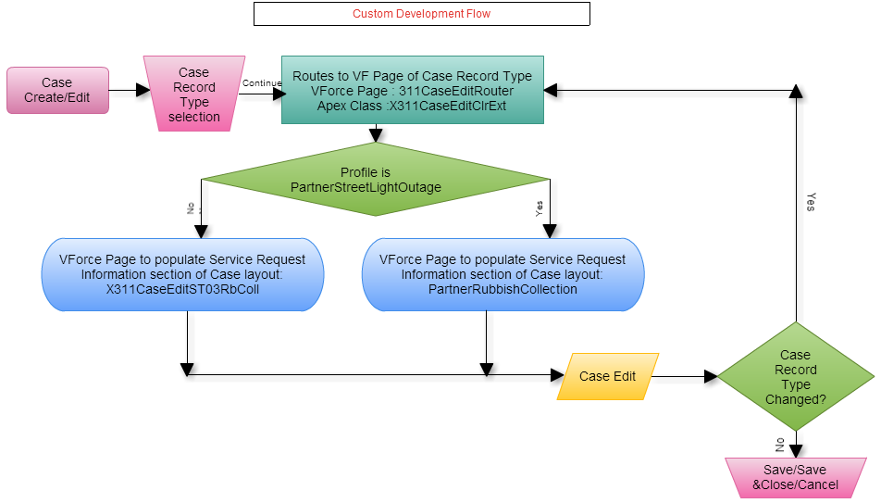

**Custom Flow :** For standard button New/Edit button is replaced with a custom Visualforce Page **X311CaseEditRouter**. All the Visual force pages and related extensions are defined as follows.

**Visual Force Page : X311CaseEditRouter**

**Purpose:**  To route to SR specific Visual force page.

<apex:page standardcontroller="Case" extensions="X311CaseEditClrExt" action="{!redir}">

</apex:page>

**Apex Class : X311CaseEditClrExt**

public PageReference redir() {

* + - 1. Get current page parameters.
      2. Get the relevant Page depending on the Profile and Record Type(X311CaseEditNS01Graffiti or PartnerGraffitiRemoval)..
      3. Redirect to the page with parameters.

}

**Visual Force Page : X311CaseEditST03RbColl**

<apex:page standardcontroller="Case">

<apex:composition template="X311CaseEdit">

<apex:define name="typeSpecific">

<apex:pageblocksection title="Service Request Information" showheader="true" collapsible="true" columns="2">

**Rubbish/Recyclable Material Collection SPECEFIC FIELDS**

</apex:pageblocksection>

</apex:define>

</apex:composition>

</apex:page>

**Visual Force Page : X311CaseEdit**

<apex:page standardcontroller="Case" extensions="X311CaseEditClrExt">

<apex:pageblock mode="edit">

<apex:pageblocksection title="Department Details">

</apex:pageblocksection>

<apex:pageblocksection title="Case Information">

</apex:pageblocksection>

<apex:pageblocksection title="Service Request Location">

</apex:pageblocksection>

<apex:inputTextArea id="caseInternalComments" >

</apex:pageblocksection>

<apex:pageblocksection title="Description Information">

</apex:pageblocksection>

<apex:pageblock>

</apex:page>

**Visual Force Page : PartnerRubbishCollection**

<apex:page standardcontroller="Case" extensions="X311CaseEditClrExt">

<apex:pageblock mode="edit">

<apex:pageblocksection title="Department Details">

</apex:pageblocksection>

<apex:pageblocksection title="Case Information">

</apex:pageblocksection>

<apex:pageblocksection title="Service Request Location">

</apex:pageblocksection>

<apex:inputTextArea id="caseInternalComments" >

</apex:pageblocksection>

<apex:pageblocksection title="Service Request Information" showheader="true" collapsible="true" columns="2">

**Rubbish/Recyclable Material Collection SPECEFIC FIELDS**

</apex:pageblocksection>

<apex:pageblocksection title="Description Information">

</apex:pageblocksection>

<apex:pageblock>

</apex:page>

**Triggers:**

|  |  |  |
| --- | --- | --- |
| **Trigger Name** | **Object** | **Description** |
| CalculateBusinessHoursAges | Case | Calculates the total business hours between when a case was opened and when it was closed and then populates “Case Age in Business Hours” field, which is displayed in the “Age to Close in Business Hours” field shown within the “Resolution Information” section of the case |
| Account_Name_Update | Contact | When a new Contact is created during the case creation process, the system does not allow for an Account to be associated to the Contact, yet Account is a required field for a Contact. Whenever a new Contact is created without an Account, this trigger will associate the Account record with Name = “City of Hampton” to the Contact record |

**Apex Code:**

**Force.com sites:**

**Javascripts:**

**Web Service/API Code:**

**Customer Portals:**

**Communities:** Community Partner Self-Service Portal

**Site.com:**

**Third Party Applications:**  Survey Force, Sales for Social Media & Call Center Console

**Other:**

**Layout**  Rubbish Collection

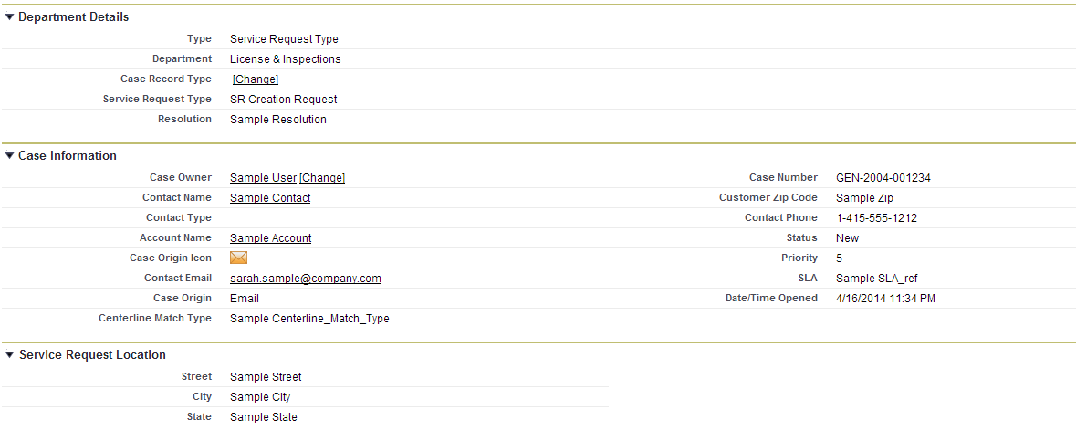

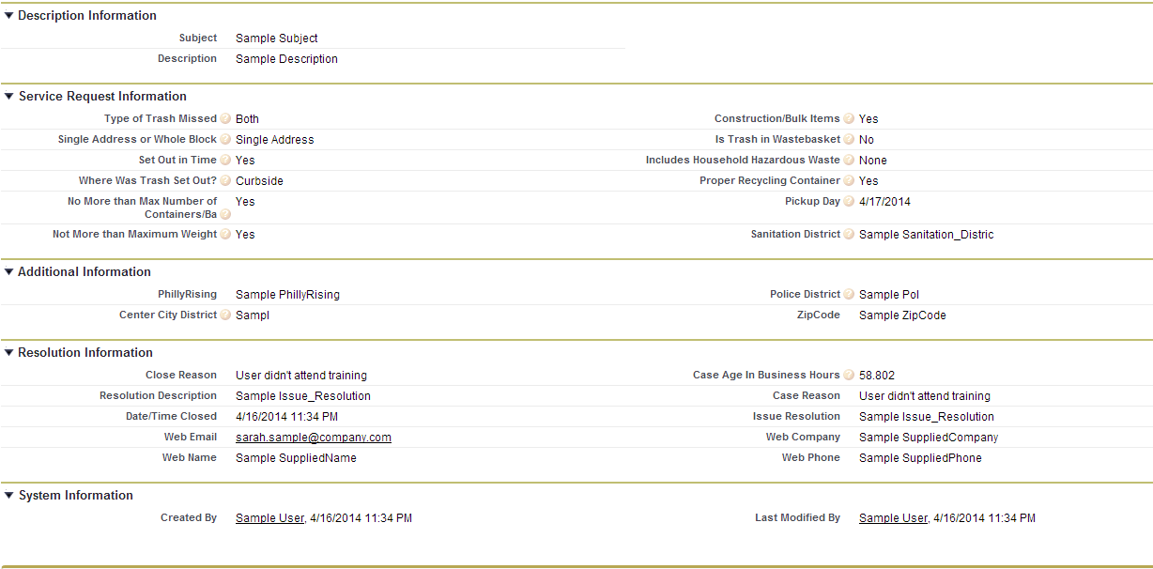

Related Lists :

* Articles
* Related Cases
* Open Activities
* Activity History
* Case Comments
* Case History
* Attachments

# 4 – STANDARD CASE FIELDS

|  |
| --- |
| 4.1 DEPARTMENT DETAILS SECTION |

|  |  |  |  |  |  |  |  |  |  |  |  |
| --- | --- | --- | --- | --- | --- | --- | --- | --- | --- | --- | --- |
| **Field Label** | **Field Name** | **Field Type** | **Custom** | **Default** | **Required** | **Unique** | **Read Only** | **External ID** | **Validation** | **History** | **Comments** |
| Type | Type | Picklist  **Values:** Service Request Type, Information Request Type, Directory Services | N | Service Request Type | Y |  | N | N | None | Y | Field is initially auto-populated based on the Case Record Type being created. If this value is manually changed, it will result in a new Field Layout based on the new Case Record Type. |
| Department | Department__c | Picklist  **Values:** Neighborhood Services | Y | Service Request Type | Y |  | N |  | None | N | Department will be automatically set based on Service Request Type. For an Information Request, this field will be automatically populated by the article. For Directory Services the field will default to 311 Services. |
| Service Request Type | Service_Request_Type__c | Picklist  **Values:** Graffiti Removal | Y | Graffiti Removal | Y |  | N |  | None | Y | This field is initially auto-populated based on the Case Record Type chosen when creating the case. If this value is changed, it could result in a new Field Layout based on the new Case Record Type chosen.  If any value in the Other Case Information systems indicates that this should not be forwarded to another department as a Service Request, a value of “Request Not Required” will be assigned to this field, which will indicate that the Case should be closed upon save without being assigned to a queue. |

|  |
| --- |
| 4.2 CASE DETAIL/INFORMATION SECTION |

**NOTE :** Section Header has to be “Case Information” in the layout when case is created or opened for modification. Other wise, Section Header is “Case Detail” .

| **Field Label** | **Field Name** | **Field Type** | **Custom** | **Default** | **Required** | **Unique** | **Read Only** | **External ID** | | **Validation** | **History** | **Comments** |
| --- | --- | --- | --- | --- | --- | --- | --- | --- | --- | --- | --- | --- |
| Case Owner | Owner | Lookup(User,Queue) | N |  | N |  | N | N | None | | Y | When a case is created this field is set to the User creating the case. Upon save, the Standard Case Assignment Rule is executed and this field is updated to a Queue based on the case’s Service Request Type. Once the case is saved this field can be manually changed by a user. |
| Case Number | CaseNumber | Auto Number | N |  | N | Y | Y | N | None | | N | The system automatically populates this field when a case is created. |
| Caller Zip Code | Caller_zip_code__c | Lookup(Contact) | Y |  | Y |  | N | N | None | | Y | This field will be populated by the Zip Code in the Contact record if one is associated with the case, otherwise the agent may populate it with a number from the caller. |
| Contact Name | Contact | Lookup(Account) | N |  | N |  | N | N | None | | Y | This field contains the Contact requesting the service. Ideally every case should have an associated contact. |
| Account Name | Account | Lookup(Account) | N |  | N |  | N | N | None | | N | This field contains the Account associated with the Contact record. |
| Parent Case | Parent | Lookup(Account) | N |  | N |  | N | N | None | | N | Two cases can be associated to each other via a parent/child relationship. This field identifies the “Parent” case. “Child” cases are displayed in the “Related Cases” Related List section for the “Parent” case. |
| Case Origin icon | Origin | Formula(Text) | Y |  | N |  | Y | N | None | | N | Shows an image representing the value in the Case Origin field. The formula for this field is: IMAGE(  CASE( Origin,  "Email", "https://<SalesforceOrg>.content.force.com/servlet/servlet.FileDownload?file=015K0000000238q",  "Phone", "https://<SalesforceOrg>.content.force.com/servlet/servlet.FileDownload?file=015K0000000238R",  "Web", "https://<SalesforceOrg>.content.force.com/servlet/servlet.FileDownload?file=015K000000023QL",  "/s.gif"),  "Origin Flag") |
| Contact Phone | ContactPhone | Phone | N |  | N |  | Y | N | None | | N | This display-only field is from the “Phone” field on the Contact record associated to the case. |
| Contact Email | ContactEmail | Email | N |  | N |  | Y | N | None | | N | This display-only field is from the “Email” field on the Contact record associated to the case. |
| Status | Status | Picklist  **Values:** On Hold, Escalated, Closed, New, In-Progress | N | New | Y |  | N | N | None | | Y | This required field defines the status of the case.   * “New” is the default value when creating a case. * All values except “Closed” are available when creating or editing a case.   “Closed” is the only value that can be selected when the “Close Case” button is used. |
| Case Origin | Origin | Picklist  **Values:** Email, Phone, Web | N | Phone |  | Y | N | N | None | | Y | This optional field provides the in-depth description of the case. |
| Priority | Priority | Picklist  **Values:** 1,2,3,4,5,6,7,8,9 | N | 5 |  | N | N | N | None | | N | This field allows a user to easily create a Comment while creating or editing a case. The data entered in this field will be used by the system to create a Comment record that will be displayed in the “Case Comments” Related List section of the case. |

## 

|  |
| --- |
| 4.3 SERVICE REQUEST LOCATION SECTION |

|  |  |  |  |  |  |  |  |  |  |  |  |
| --- | --- | --- | --- | --- | --- | --- | --- | --- | --- | --- | --- |
| **Field Label** | **Field Name** | **Field Type** | **Custom** | **Default** | **Required** | **Unique** | **Read Only** | **External ID** | **Validation** | **History** | **Comments** |
| Street | Street__c | Text(255) | Y |  | N |  | N |  |  |  | Street of the Service Request Location. Also see Standard Workflow Rules. |
| City | City__c | Text(255) | Y |  | N |  | N |  |  |  | City of the Service Request Location. Also see Standard Workflow Rules. |
| State | State__c | Text(255) | Y |  | N |  | N |  |  |  | State of the Service Request Location. Also see Standard Workflow Rules. |

|  |
| --- |
| 4.4 CASE LOCATION SECTION |

Defined in GIS Integration Detailed Design Document.

|  |
| --- |
| 4.5 DESCRIPTION INFORMATION SECTION |

|  |  |  |  |  |  |  |  |  |  |  |
| --- | --- | --- | --- | --- | --- | --- | --- | --- | --- | --- |
| **Field Label** | **Field Name** | **Field Type** | **Custom** | **Default** | **Required** | **Read Only** | **External ID** | **Validation** | **History** | **Comments** |
| Subject | Subject | Text(255) | N |  | Y | N |  |  | Y | If this field is populated when creating a new case, the system will find and display Knowledgebase Articles using the content in the “Subject” field. |
| Description | Description | Long Text Area(32000) | N |  | Y | N |  |  | Y | This optional field provides the in-depth description of the case. |
| Internal Comments | Comments | Text Area(4000) | N |  | N | N |  |  | N | This field allows users to enter a Comment while creating or editing a case. Data entered in this field will be used by the system to create a Comment record that will be displayed in the “Case Comments” Related List section of the case. |

|  |
| --- |
| 4.6 RESOLUTION INFORMATION SECTION |

NOTE: Case Detail page have these fields only be populated if the case is “closed”.

| **Field Label** | **Field Name** | **Field Type** | **Custom** | **Default** | **Required** | **Read Only** | **External ID** | **Validation** | **History** | **Comments** |
| --- | --- | --- | --- | --- | --- | --- | --- | --- | --- | --- |
| Close Reason | Close_Reason__c | Formula (Text) Formula : TEXT(Reason) | Y |  | N | Y |  |  | N |  |
| Resolution Description | Resolution_Description__c | Formula (Text) Formula : TEXT(Issue_Resolution__c) | Y |  | N | Y |  |  | N |  |
| Date/Time Closed | ClosedDate | Date/Time | N |  | N | Y |  |  | N |  |
| Age to Close in Business Hours | Age_to_Close_in_Business_Hours__c | Formula(Number) | Y |  | N | Y |  |  | N | CalculateBusinessHoursAges trigger would update this field |
|  |  |  |  |  |  |  |  |  |  |  |

NOTE: Following fields is shown in Resolution Info section.

|  |  |  |  |  |  |  |  |  |  |  |
| --- | --- | --- | --- | --- | --- | --- | --- | --- | --- | --- |
| **Field Label** | **Field Name** | **Field Type** | **Custom** | **Default** | **Required** | **Read Only** | **External ID** | **Validation** | **History** | **Comments** |
| Case Age in Business Hours | Case_Age_In_Business_Hours__c | Number(15,3) | N |  | N | Y |  |  | Y | CalculateBusinessHoursAges trigger would update this field |
| Case Reason | Reason | Picklist Values: Emergency Call, Invalid, Other, Question Answered | N | Question Answered | Y | N |  |  | Y |  |
| Issue Resolution | Issue_Resolution__c | Text Area(255) | Y |  | N | N |  |  | Y |  |

## 

|  |
| --- |
| 4.6 WEB INFORMATION SECTION |

NOTE: Section is shown only when the case is created through social media channels.

| **Field Label** | **Field Name** | **Field Type** | **Custom** | **Default** | **Required** | **Read Only** | **External ID** | **Validation** | **History** | **Comments** |
| --- | --- | --- | --- | --- | --- | --- | --- | --- | --- | --- |
| Web Email | SuppliedEmail | Email | N |  | N | Y |  |  | N |  |
| Web Name | SuppliedName | Text(80) | N |  | N | Y |  |  | N |  |
| Web Company | SuppliedCompany | Text(80) | N |  | N | Y |  |  | N |  |
| Web Phone | SuppliedPhone | Text(40) | N |  | N | Y |  |  | N |  |

|  |
| --- |
| 4.7 SYSTEM INFORMATION SECTION |

|  |  |  |  |  |  |  |  |  |  |  |
| --- | --- | --- | --- | --- | --- | --- | --- | --- | --- | --- |
| **Field Label** | **Field Name** | **Field Type** | **Custom** | **Default** | **Required** | **Read Only** | **External ID** | **Validation** | **History** | **Comments** |
| Created By | CreatedBy | Lookup(User) | N |  | N | Y |  |  | N |  |
| Last Modified By | LastModifiedBy | Lookup(User) | N |  | N | Y |  |  | N |  |

Additional comments: